INTI International College Penang School of Computing
3+0 Bachelor of Science (Hons) in Computer Science, in collaboration with Coventry University, UK 3+0 Bachelor of Science (Hons) in Computing, in collaboration with Coventry University, UK

Coursework cover sheet

Section A - To be completed by the student.

Full Name: Desmond Kok Weng Hin
CU Student ID Number: 14196612
Semester: First semester
Session:
April 2023
Lecturer:
Puteri Nursyawati Azzuri (puteri.azzuri@newinti.edu.my)
Module Code and Title:
4067CEM Software Design
Assignment No. / Title:  Continuous Assessment | % of Module Mark:  50
Hand out Date:  12 May 2023 | Due Date:  Task 1: 02 June 2023, by 11.59pm.  Task 2: 07 July 2023, by 11.59pm  Task 3: 23 June 2023, by 11.59pm.  Task 4: 23 June 2023, by 11.59pm.  Task 5: 23 June 2023, by 11.59pm.
Penalties: No late work will be accepted. If you are unable to submit coursework on time due
to extenuating circumstances, you may be eligible for an extension. Please consult the lecturer.
Declaration: I/we the undersigned confirm that I/we have read and agree to abide by the University regulations on plagiarism and cheating and Faculty coursework policies and procedures. I/we confirm that this piece of work is my/our own. I/we consent to the appropriate storage of our work for plagiarism checking.

Signature(s):

Section B - To be completed by the module leader

Intended learning outcomes assessed by this work:
- Understand and apply appropriate concepts, tools, and techniques to each stage of the software development.
- Understand and apply design patterns to software components in developing new software.
- Demonstrate an understanding of project planning and working to agreed deadlines, along with professional, interpersonal skills and effective communication required for software production.
5. Demonstrate an awareness of, and ability to apply, social, professional, legal, and ethical standards as documented in relevant laws and professional codes of conduct such as that of
the Malaysian National Computer Confederation.
Marking scheme | Max | Mark
1. User Story Mapping | 20
2. Setting up a GitHub
Repository | 10
3. Creating a Class diagram and
design pattern selection | 30
4. Creating a Prototype User
Interface and Usability Testing | 20
5. Discuss the ethical issue
related to the software | 20
Total | 100

The 4067CEM assessment should be completed as a full individual work over the course of the module. The assessment output are only judged at the end of the module and not by the expectations during that week. The assessment should be undertaken individually. All submissions will be checked against each other and the internet for possible plagiarism.

Activities – These activities consist of 50% of your coursework marks. It will be run throughout the semester and there will be a final submission at the end of the semester. These activities consist of activities that will be done in a software design phase.

System

Student Business System for College.

Task 1 – User Story Mapping (20 marks)

The first thing that you need to do is ask the user what they wished for in a system. The user here can be your friends as the system is related to them. Get at least 10 real users to get their feedback. Document their feedback. Use software like Trello to complete this activity.
Output – All the user stories, and backlog with goals, activities, and tasks. In Word format, uploaded it to GitHub.
Due – Week 9 of the semester. 02 June 2023, by 11.59 pm.

Task 2 – Setting up a GitHub Repository (10 marks)

This is where the output of the tasks will be stored, Make sure you register an account, create a repository and your files are uploaded here and it is in an organized manner and can be easily found.
Output – GitHub Repository with Task 1, Task 3, Task 4 and Task 5 documents. Take note the date of the files will be shown so you must follow the due date of each task.
Due – It will be accessed on Week 14 of the semester. 07 July 2023, by 11.59 pm

Task 3 – Creating a Class diagram and design pattern selection (30 marks)

Create a simple Class diagram which should consists of the Classes that might be used to represent the system and the association between them. You don’t have to declare the attributes and operations for this activity. You do have to explain the class responsibility of each class declared. You can use software like StarUML to complete this activity.
Output – A class diagram containing classes and associations. In Word format, uploaded it to GitHub.

Consider the problem and select a suitable design pattern that can be implemented on the problem. Give justification on why the design pattern was chosen. Draw the UML diagram representing your class diagram as a design pattern UML. Include all the abstract class/interface, concrete class, and inheritance (if any) used to represent the problem.
Output – UML diagram representing the design pattern. In Word format, uploaded it to GitHub. Due – Week 12 of the semester. 23 June 2023, by 11.59 pm.

Task 4 – Creating a Prototype User Interface and Usability Testing (20 marks)

Create a Prototype User Interface (hand drawn/digital) of TWO (2) important functions of the proposed system. Come up with usability testing questions. You don’t have to carry out the test, just prepare the questions. You should indicate what you are testing for in the Usability Testing.
Output – A Prototype and Usability Testing Questions. In Word format, uploaded it to GitHub. Due – Week 12 of the semester. 23 June 2023, by 11.59 pm.

Task 5 – Discuss the ethical issue related to the software (20 marks)

Discuss and do a critical analysis of your software in these areas, privacy concerns, intellectual property rights, and effects on society.
Output – A report in Word format, uploaded to GitHub.
Due – Week 12 of the semester. 23 June 2023, by 11.59 pm.

Submission

All tasks needed to be documented in Word format and submitted for SafeAssign checking (Links will be provided before the due date).
Upload the document and the SafeAssign report to your GitHub repository by each task due date. Due – It will be accessed on Week 14 of the semester. 07 July 2023, by 11.59 pm

Marking Rubric for Continuous Assessment

 | Marks Below 40% | Marks in the range 40 – 49% | Marks in the range 50 – 59% | Marks in the range 60 – 69% | Marks 70% and above
User Story | User Story Mapping | User Story Mapping | User Story Mapping | User Story Mapping | User Story Mapping done and does capture most important activities of the system. The breakdown of the user story mapping is excellent and uses software that can assist that process (For example Trello compared to Ms.  Word).
Mapping | not done or User | done at a minimum | done and does | done and does
(20 marks) | Story copied/does  not match the exact | level and does not  capture the | capture several  important activities of | capture several  important activities of
 | system. | important activities of | the system. The | the system. The
 |  | the system. | breakdown of the | breakdown of the user
 |  |  | user story mapping | story mapping is good
 |  |  | can be improved. | and uses software that
 |  |  |  | can assist that
 |  |  |  | process (For example
 |  |  |  | Trello compared to
 |  |  |  | Ms. Word).
Setting up a | GitHub repository | GitHub repository | GitHub repository | GitHub repository exist | GitHub repository
GitHub | does not exist or | exist and some of | exist and most of the | and all of the required | exist and all of the
Repository | cannot be accessed | the required files are | required files are | files are available at | required files are
(10 marks) | or the required files  are not available at | not available at the  time of access. | available at the time  of access. However | the time of access.  However the dates for | available at the time  of access. The dates
 | the time of access. |  | the dates does not | some files does not | on the files follows
 |  |  | follow the required | follow the required | the required
 |  |  | deadline. | deadline. | deadline.
Creating a | The Class diagram | The Class diagram | The Class diagram | The Class diagram | The Class diagram
Class diagram | does not represent | and design pattern | and design pattern | and design pattern | and design pattern
and design pattern selection (30 marks) | the required solution (contains generic or non- related classes  such as admin), the design pattern | represent the required solution but in a very general and incomplete way.  Required classes in | represent the required solution in a partial way. A few  required classes in the design are not | represent the required solution in a satisfactory way. Most  required classes are declared. | represent the required solution in an excellent way. All  required classes are declared.
 | suggested is not | the design are not | declared.
 | suitable for the given | declared.
 | problem.

Creating a Prototype User Interface and Usability Testing  (20 marks) | No prototype were available or the measurement for the usability testing is not clear. | The prototype cover minimalist and trivial design (such as login) and the measurements for the usability testing are not clear. | The prototype cover adequate design and several measurements for the usability testing are not clear. | The prototype cover good design and most measurements for the usability testing are clear. | The prototype cover excellent design and all measurements for the usability testing are clear.
Discuss the ethical issue related to the software  (20 marks) | There is no discussion on the ethical issue or only the theories are pasted back for this component. | There is an attempt to discuss on the ethical issue but no critical  analysis was done | There is an attempt to discuss on the ethical issue with some critical analysis was done | There is an attempt to discuss on the ethical issue with good critical analysis. | There is an attempt to discuss on the ethical issue with excellent critical analysis.

Task 3
3.1 Class Diagram
A class diagram is a graphical representation in the Unified Modelling Language (UML) that defines and shows the structure and relationships between classes. It serves numerous purposes including visualizing, documenting and constructing executable software code for different aspects of the system.
Class diagrams play a crucial role in software development as they are the main type of UML diagram. They provide the ability to create models using attributes, relationships, operations and intersections. Class diagrams serve as the optimal way to depict a system’s structure in a comprehensive manner. The purpose of class diagrams is to analyse and design the static view of an application, depict system responsibilities, as well as enable both forward and reverse engineering processes.
The Class Diagram is typically divided into three main sections which is the upper section, middle section and lower section. The upper section contains the name of the class, the middle section comprise the attributes and the lower section covers the methods or operation. (tutorialspoint, n.d.)

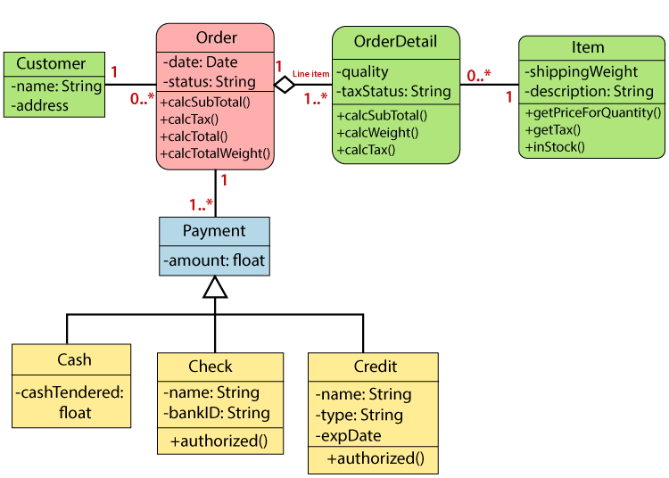
Diagram 1.1 Class Diagram Example (javatpoint, n.d.)

3.2 Design Pattern
A design pattern is a standardized and reusable solution to a common problems or challenges encountered in software design.
There are three primary types of design patterns including Creational, Structural and Behavioral patterns. Creational design patterns focus on class instantiation and can be subdivided into class-creation patterns and object-creation patterns.
On the other hand, Structural design patterns involve the organization of diverse classes and objects. Lastly, Behavioral design patterns centre on the identification and implementation of recurring communication patterns among objects. (GeeksforGeeks, 2023)

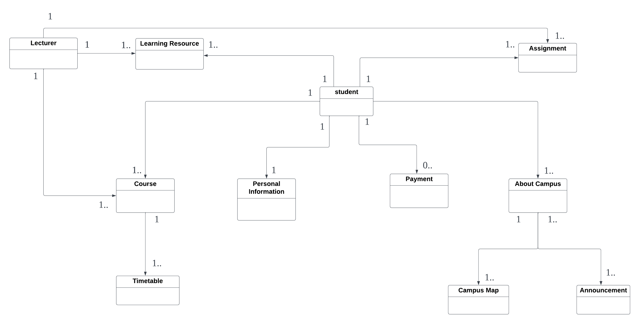
Diagram 1.2 Class Diagram

3.3 Class Descriptions for Student Business System

The “Student” class represents the users who interact with the student business system.
The “Personal Information” class represents the students’ personal information, such as their name, email, phone number.
The “Course” class represents the courses offered by the school.
The “Timetable” class represents the assigned lecturer, class details and schedule time.
The “Payment” class represents all the relevant details of payment by a student for tuition or other fees.
The “About Campus” class represents all the information about the campus, such as maps and announcements.
The “Announcement” class represents announcement notices from the school.
The “CampusMap” class represents the campus maps and directions to various locations on campus.
The “LearningResource” class represents files uploaded by lecturers for students to access as learning resources.
The “Assignment” class represents the student’s submission for an assignment.
The “Lecturer” class represents the lecturer of the school.

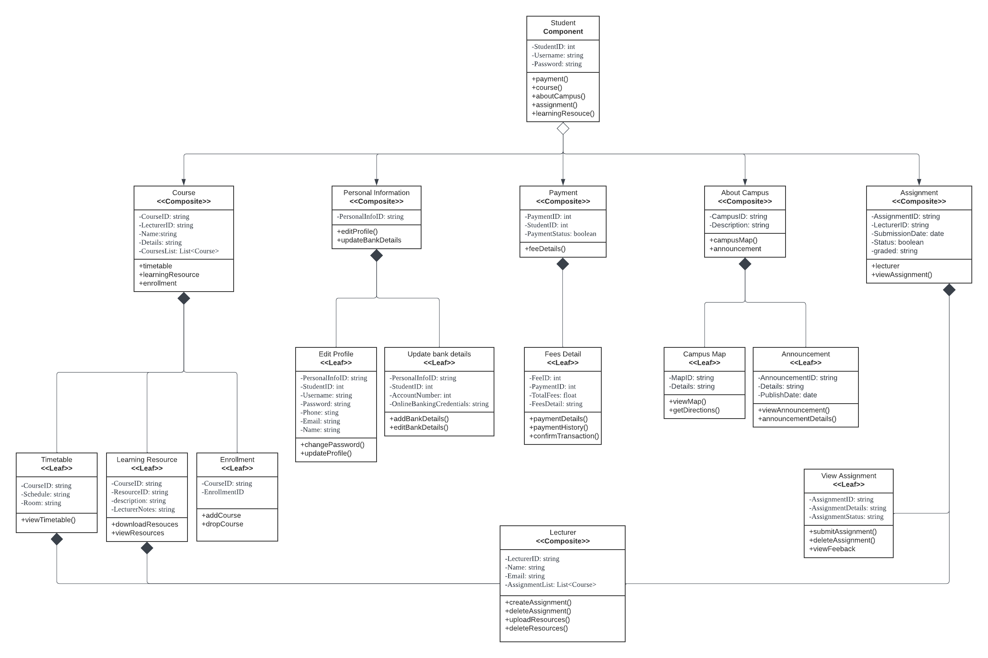
Diagram 1.3 Structural Design Pattern

3.4 Structural Design Pattern
I have deliberately chosen to integrate the Structural Design Pattern for the student business system as shown in Diagram 1.3. This deliberate choice provides a numerous of advantages by enabling each class or object to focus on performing its specific functions thereby empowering the system’s ability to be easily maintained and modified. Additionally, Structural design patterns offer a clear structure that aids users in better understanding the system’s components. The composite pattern is an excellent choice for illustrating the hierarchical relationships among classes in the student business system as it allows for effective management and seamless collaboration of the items within the system.

3.5 Considered Problem
The problem addressed in the Student Business System is complex scalability, which can lead to poor system performance and pose challenges in system management.
Poor system performance can cause slowdowns, delays or even crashes. This will negatively impact the user experience. Additionally, as the system grows complexity, it becomes more challenging to manage including the process of adding new features or making changes to existing one. This can result in longer development cycles and a higher risk or errors.
To tackle this issue, the integration of a structural design pattern plays a crucial role. The system becomes more scalable and easier to manage when using the composite pattern as it simplifies the handling of individual objects and groups, enabling effective handling of hierarchical relationships.

References

Tutorialspoint (n.d.) UML – Class Diagram [online] Available at: https://www.tutorialspoint.com/uml/uml_class_diagram.htm (Accessed: 20 June 2023)

GeeksforGeeks (2023) Introduction to Pattern Designing [online] Available at: https://www.geeksforgeeks.org/introduction-to-pattern-designing/ (Accessed: 20 June 2023)

